

**DEDAN KIMATHI UNIVERSITY OF TECHNOLOGY**

**FACULTY OF BUSINESS, COMPUTER SCIENCE AND INFORMATION TECHNOLOGY**

**DEPARTMENT OF COMPUTER SCIENCE**

**REPORT ON AN ATTACHMENT FIELD**

**AT NATIONAL SOCIAL SECURITY FUND (NSSF) NAIROBI**

**FROM 17TH JANUARY TO 8TH APRIL**

**PRESENTED BY**

**NAME: MUSANGI MBOYA**

**REGISTRATION NO: C027-01-1392/2019**

**SUPERVISING LECTURER: MICHAEL MUCHIRI**

**REPORT SUBMITTED TO DEPARTMENT OF INFORMATION TECHNOLOGY IN COMPUTER SCIENCE IN A PARTICULAR FULFILLMENT OF THE REQUIREMENTS FOR THE DEGREE OF BACHELOR OF BUSINESS INFORMATION TECHNOLOGY**

**DATE OF SUBMISSION: 8TH APRIL 2022**

# **DECLARATION AND CONFIRMATION**

**Declaration by the student**

I ……………………………………………. declare that this is my original work and has not been presented anywhere else to the best of my knowledge.

Signature: __________________ Date: ___/____/______

**Confirmation by the supervisor**

I ……………………………………………. confirm this report has not been presented anywhere else to the best of my knowledge.

Signature: __________________ Date: ___/____/______

# **DEDICATION**

This report is dedicated to parents for their financial support they accorded me during my studies.

# **ACKNOWLEDGEMENT**

I would like to thank God for the continuous grace He has shown me all through upto this point and having seen me through the successful completion of my attachment.

Special thanks also to my Industry supervisors, Ms. Margret, Mr. Stephen Omwanda and the entire NSSF ICT staff including Brian Amugada and my fellow attachés for the assistance and training offered to me.

Final appreciations to my guardian and siblings for their unwavering support and encouragement throughout my studies.

# **ABSTRACT**

This report is a compilation of the 17th January – 8th April, 2022 that is 12 weeks’ industrial attachment I had at National Social Security Fund (NSSF) Nairobi, in the Information Communication and Technology (ICT) Section. It encapsulates the work done during this period, challenges encountered and includes suggestions and recommendations on how to respond to the problems faced. It contains highlights of specific tasks performed, strong and weak points of the attachment as compared to the current education curriculum.

**Table of Contents**

**DECLARATION AND CONFIRMATION** i

**DEDICATION** ii

**ACKNOWLEDGEMENT** iii

**ABSTRACT** iv

**LIST OF TABLES** v

**LIST OF FIGURES** vi

**LIST OF SYMBOLS AND ABBREVIATION** vii

**CHAPTER 1: INTRODUCTION** 1

**1.1: A brief Introduction of NSSF** 1

**1.1.1 Objectives of NSSF** 1

**1.1.2 Mission of NSSF** 1

**1.1.4 Core values of NSSF** 1

**1.2: Purpose and objectives of Attachment** 2

**1.3. Regulations to interns and attachés** 2

**1.4: Benefits of Attachment** 2

**1.5: Methodology of Learning** 3

**1.7: Challenges faced during the attachment** 4

**CHAPTER 2: DESCRIPTION OF ATTACHMENT** 5

**2.1: Overview of NSSF** 5

**2.2: Organizational Structure** 5

**2.2.1: Departments at NSSF** 7

**2.3: Brief description of the NSSF’s ICT Department** 7

**2.4 Tools and equipment used during the attachment** 10

**2.5. Work Schedule** 10

**CHAPTER 3: OFFICE AUTOMATION AND SOFTWARE EMPLOYED** 12

**3.1 General overview of the office automation and software in the Fund.** 12

**3.2 Management of IS/IT** 13

**3.3 Organization of Computer networks** 13

**3.4 System Software** 14

**3.5 Social Security and Pensions Administration System (SSPAS).** 14

**3.6: 5000s Series Task alfa printer** 17

**3.7: SAP** 18

**3.8 Oracle Database** 18

**3.8.1: Oracle Database features** 18

**CHAPTER 4: REFLECTION AND CONCLUSION OF ATTACHMENT** 20

**4.1 Recommendation** 21

**APPENDICES** 22

**NSSF Mission and Vision.** 22

**Guidelines for students on industrial attachment** 23

**Student’s logbook snapshots** 24

**TASK alfa 5053ci multifunctional printer** 26

**ICT Department.** 27

**Attachment schedule.** 27

**Learning Components of a computer.** 28

**REFERENCES** 30

**TABLE OF FIGURES**

Figure 1 Organization structure 6

Figure 2 NSSF ICT Department structure 9

Figure 3 General topology 14

Figure 4 SOA architecture 15

Figure 5 TASK alfa 5053ci multifunctional printer 23

Figure 6 ICT Department. 24

Figure 7 Learning Components of a computer motherboard. 25

# **LIST OF SYMBOLS AND ABBREVIATION**

1. NSSF - National Social Security Fund also referred to as Fund.
2. ICT - Information and Communications Technology.
3. MFP - Multifunction Printers.
4. EDMS - Electronic Document Management System.
5. SSPAS - Social Security and Pensions Administration System.
6. SAP - System Analysis Program Development.
7. IS - Information Security.
8. MS - Microsoft.
9. ISP - Internet Service Provider.
10. OS - Operating System.
11. ISO - International Organization for Standardization.
12. SOP - Standard Operating Procedure.
13. MDC- Modular Data Centre
14. NAC- Network Access Control

Industrial Attachment is a structured, credit-bearing work experience in a professional work setting during which the student applies and acquires knowledge and skills.

The Ministry is a government department under the direction of a Cabinet Secretary.

# **CHAPTER 1: INTRODUCTION**

## **1.1: A brief Introduction of NSSF**

National Social Security Fund (NSSF) is a state parastatal established in 1965 by an Act of Parliament Cap 258 of the Laws of Kenya. Initially it was overseen by the Department of the Ministry of Labour until 1987 when it was transformed into a State Corporation under the Management of a Board of Trustees. The company’s mission is to provide adequate income replacement to members through prudent investments and prompt payment of benefits. Its vision is to be a trusted and reliable social security provider in the country. It is a friendly service organization that exists for the public good (Overview of NSSF, n.d.).

It provides social security protection to individuals and households to ensure access to health care and to guarantee income security, particularly in cases of old age, unemployment, sickness, invalidity, work injury, maternity or loss of a breadwinner.

NSSF headquarters are at NSSF Building, Bishops Road, Nairobi, Kenya.

### **1.1.1 Objectives of NSSF**

* To be the trusted Social Security provider

### **1.1.2 Mission of NSSF**

To provide adequate income replacement to members through prudent investments and prompt payment of benefits.

### **1.1.4 Core values of NSSF**

* Customer Focus.
* Integrity.
* Accountability.
* Innovation
* Team Work

## **1.2: Purpose and objectives of Attachment**

Attachment provides opportunities for students to meet future employers in their field and to also know what they are expected to do while in their areas of specialization as part of the workforce. Students also equip themselves with interpersonal skills through meeting with professionals in their field of study. Some of the objectives that I formulated while proceeding to attachment were as follows

* To get the chance to put the knowledge gained at the university into practice.
* To make contacts with prospective future employers.
* To learn how different departments, rely on IT to be able to meet their goals.
* To learn the different technologies employed in the current enterprise world.

## **1.3. Regulations to interns and attachés**

* Reporting time: It is required all attaches report at 8.00 am, and depart 5. 00p.m, or the time when the industry supervisor releases them.
* Attendance signing: It is required that all interns/attaches register the time they arrive and depart which is on Mondays and Fridays,
* All interns/attaches are expected to have their intern’s/attaché’s identification card all the time.
* All attaches should record everyday on problems they solved in the task book provided.

## **1.4: Benefits of Attachment**

* During the attachment period there is a lot of knowledge and skills that I have learn ned. In a general view, teamwork and co-operation among the members in an organization increases efficiency and hence increased task completion. The aim of the organization is rooted in customer satisfaction through completion of tasks in the desired time. My communication and negotiation skills while handling end user issues has been sharpened greatly enabling me to be able to handle pressure while on work place.
* The attachment has also provided me with an opportunity to appreciate the theoretical knowledge and principles of Computer Science in solving various challenges in the ICT field. In addition, concepts of the various applications of algorithms such as shortest path were well grasped during this attachment period.
* I also learned various troubleshooting skills for various Microsoft applications and the Kyocera Task alfa network shared printer as well as SSPAS and SAP applications which are used in many different departments for running various duties.
* The concepts and skills I learned during this attachment have equipped me with necessary skills needed for future job employment opportunities.
* I also learnt how migration process of data centre is done, how to rack servers, configuration of servers and storage units, virtualization resources in an organization and different challenges that arise during the migration process and how to fix them in due time.
* Learnt on how to configure switches and routers.
* Also managed to set up network as attaches with two branches i.e. Lamu and Kisii and established communication path to headquarters.

## **1.5: Methodology of Learning**

While the ICT department has various sections, the section I was posted to was the help desk section. This section is responsible for handling various ICT related issues arising from the different users in the organization. These issues are experienced on daily bases. They may be from either hardware related including printer issues or software related.

The main methods of learning were

a) Consequent meetings and lectures by the supervisors primarily meant to impact knowledge and skills of solving challenges that have never been solved by my fellow attachés or the interns. This really assisted in keeping with up-to-date solutions for the current common applications such as Microsoft Office issues, printer issues and also routers related issues.

b) Being taken through the various concepts and principles of the organizations by my fellow attaches and interns that were already present in the organization before me. Through them I learned to troubleshoot common problems that end users experience while working with their personal computers.

c) Other notable methodologies included; Reading past solutions on the problems experienced by users of similar challenges, which is documented daily in the “task book” of the organization, observations and researching on solutions for different problems using various online platforms including Microsoft Community platforms, etc. These methods proved really useful and time conscious since solutions for some particular problems could be found easily since most of the current challenges are just a repetition of the past challenges.

## **1.7: Challenges faced during the attachment**

The major challenge I encountered was familiarizing myself with different SOPs for some detailed processes or jobs. An instance of this was during configuration of Avaya 3550GT series switch, sometimes it was difficult to remember some configuration commands since its different from Cisco switches. However, with time, notes taking and repetition of the same procedure I was able to grasp the required knowledge. The other challenge is that, some of staff were impatience when trying to solve their problems while others looked down upon us and felt unsatisfied by attaches solving their problems.

# **CHAPTER 2: DESCRIPTION OF ATTACHMENT**

## **2.1: Overview of NSSF**

According to the NSSF website, The Fund was established in 1965 through an Act of Parliament Cap 258 of the Laws of Kenya. The Fund initially operated as a Department of the Ministry of Labour until 1987 when the NSSF Act was amended transforming the Fund into a State Corporation under the Management of a Board of Trustees.

The act was established as a mandatory national scheme whose main aim was to provide basic financial security benefits to Kenyan upon retirement. The Fund was set up as a Provident Fund providing benefits in the form of a lump sum

The National Social Security Fund (NSSF) Act, No.45 of 2013 was assented to on 24th December, 2013 and commenced on 10th January, 2014 thereby transforming NSSF from a Provident Fund to a Pension Scheme to which every Kenyan with an income shall contribute a percentage of his/her gross earnings so as to be guaranteed basic compensation in case of permanent disability, basic assistance to needy defendants in case of death and a monthly life pension upon retirement. (‘NSSF, Background’, n.d)

The Act establishes two Funds namely, the Pension Fund and the Provident Fund, to provide for contributions to and payment of benefits out of the Funds.

## **2.2: Organizational Structure**

NSSF is a tripartite organization run by the Government, workers and employers with representation from the board of trustees, the Government, Federation of Kenya employers and the Central Organization of Trade Unions – Kenya. In formulating the Fund’s policies, the Board of Trustees acts strictly in accordance with the NSSF Act, which places the best interests of NSSF members above all other considerations. (“NSSF Organizational Structure,” n.d.)

The diagram below represents the organizational structure.

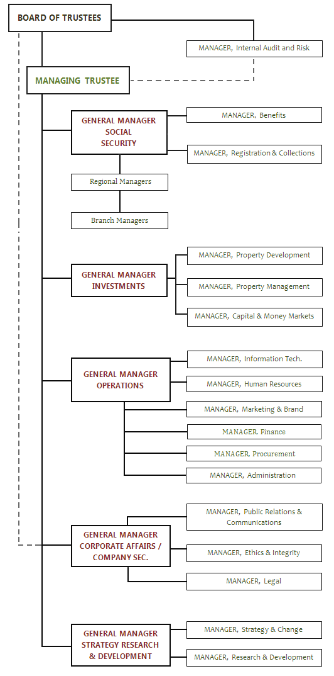

Figure 1 Organization structure

Courtesy of: https://www.nssf.or.ke/organization-structure

### **2.2.1: Departments at NSSF**

* Administration

The department is involved in planning of the Fund’s activities, organization of the Fund, directing the various departments and controlling the Fund’s actions.

* Benefits

Involved in the processing of benefits payments as well as claims launched by members,

* Marketing

Involved in the managing and monitoring of investment opportunities and ventures.

* Ethics and Integrity

Oversees ethical issues as well as monitoring corruption cases whenever reported.

* Finance

Regulates the flow of finances used in expenses and purchases within the organization.

* Human Resources

Involved in managing recruitment exercises, staff affairs as well as training exercises General staff management.

* Information Communication Technology (ICT)

The ICT department provides the computing and network support needed to drive the business agendas.

## **2.3: Brief description of the NSSF’s ICT Department**

The ICT department is under the general operations wing. It is headed by the manager, Mr. Stephen Obare. Below is the ICT department chart which is also referenced in incident reporting procedure.

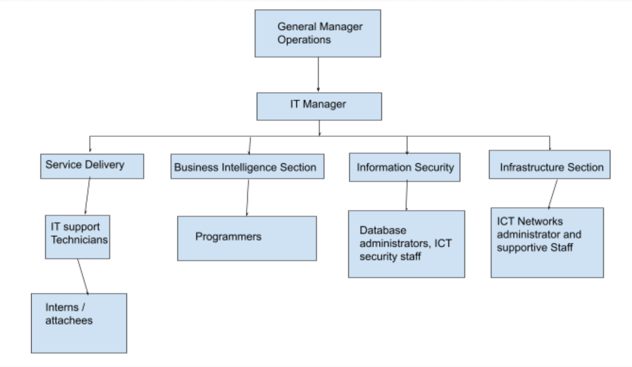

Figure 2 NSSF ICT Department structure

##### **Service Delivery.**

This section is responsible for handling day to day IT operational support to the staff of the whole Fund. Notable responsibilities include the following;

* Configuration of the printers and the scanners.
* Troubleshooting the software, hardware and the network related problems.
* New hardware and software installation.
* Computer, laptop, printer and scanner maintenance.
* Antivirus software and operating system upgrade.
* Oracle database installation, configuration and updating.
* Providing help desk services to members of the staff.

##### **Infrastructure section.**

The section is responsible for management of Modular Data Centre (MDC), network and hardware. Other responsibilities being conducted by this section include;

* Creation and update of different VLANs and active directories.
* Connecting the computers and IP phones to the networking media and equipment.
* Acquisition of ICT equipment e.g., network devices, printers, scanners and laptops, through the procurement department and general management of these devices.
* Distribution of the ICT equipment to the users especially the desktops and the laptops.
* Allocation of the shared equipment e.g., printers.
* General repairs of the network and IT equipment.
* General cabling and networking.

##### **Information Security.**

This section maintains the integrity of the NSSF network system and data.

Other functions conducted by this section include;

* Protecting fund’s computers, networks and data against threats including security breaches, computer virus or by cyber-attacks.
* Monitoring the network and application performance to identify any irregular activity.
* Setting and implementing user access controls and identifying and accessing the management systems.
* Making recommendations of the best antivirus to be used by the organization.

##### **Business Systems section.**

Technology eases the organization's effort in achieving its goals. And under this section, the main concern is with alignment of technological solutions to business needs. The main responsibility conducted by this section is the identification of efficient and relative software application systems. It’s also involved in the support of the fund’s decision-making process and to help knowledge workers including the managers and research analysts to make faster and better decisions get in

## **2.4 Tools and equipment used during the attachment**

The various tools and equipment used during the attachment period are listed below:

* Crimping tool
* Punch-down tool
* Testers (one for testing power in cables and the other for testing network cables)
* Ubuntu, Windows 7/8/8.1/10 operating systems
* Printer software drivers
* RJ-45
* CAT 5 and 6 network cables
* Visual Basic 6.0
* Oracle database 10g client
* SSPAS software
* SAP software

## **2.5. Work Schedule**

The supervisor assigned me to each of the sections for a period of three weeks each. During this period, I was supposed to familiarize myself with the various activities undertaken by the particular section within the ICT department.

The supervisors were keen to note any challenge I was facing and would quickly assist where necessary.

A classical working day would start at 8:00 am and end at 5:00 pm.

My attachment schedule was as follows;

1. 17/01/2022 to 4/02/2022- Service Delivery.

I was acquainted with the service delivery section and showed the various services offered by the ICT department in the organization under this section.

1. 7/01/2022 to 25/02/2022- Infrastructure section.

Various infrastructures in the ICT department of the organization were demystified to me by my industrial supervisor.

1. 28/02/2022 to 18/03/2022- Information Security.

I was taken through the information security in the organizations by the various heads of the security section. I was taught various IS concepts such as access control, internet usage restrictions, physical security, media disposal policy, Password and Credential Guidelines.

1. 21/03/2022 to 8/04/2022- Business systems section.

I was taken through the business section by the heads of the Business systems heads. We were taken through the servers and various network management sections which are used in the organizations.

# **CHAPTER 3: OFFICE AUTOMATION AND SOFTWARE EMPLOYED**

## **3.1 General overview of the office automation and software in the Fund.**

Office automation is the process of watching data flow around on its own without any human intervention, inaccuracies, and errors. An automation tool is used to create, collect, store, analyse, and share confidential office data that is required to accomplish basic day-to-day routine tasks and processes effectively.

At NSSF various tools and software have been employed to help ease the work of employees. Most notable is the Microsoft suite, MFPs, automated paper punch, etc. With MFPs, there is a system that detects the level of ink in the cartridges and notify the user whenever the level is below the required. The main type of printer used is the Kyocera Task alfa Series. The printer is multifunctional. Unlike other printers, when using the Kyocera Task alfa Series printer one would need a special pin. The jobs of type “scan” are forwarded to the institutional email account of the individual user. This helps promote security, privacy, proper utilization and monitoring of resources.

Various Microsoft productive tools used at NSSF include the Outlook mail platform, Teams, Word, Excel among others. The software is up to date and maintained by the ICT department. Outlook is used for information management and sending, receiving, and storing emails. However, it can also be used as a personal information management tool, as it incorporates a personalized calendar and lists of contacts, tasks, notes, and comments. For real time communication Teams platform is used (Patel, 2015).

Office calls are made using Avaya phones. Avaya is one of the world's leaders in business collaboration and communication solutions. They provide unified communications, real-time video collaboration, contact centre, networking and related services to companies of all sizes worldwide, (*What Is Avaya?* n.d.).

Due to ISO recommendations, the main OS installed that is used at the NSSF is Windows 10 and the antivirus is Kaspersky.

Other software includes the SSPAS and the SAP which are used in achieving the roles of the organization. SAP collects and processes data from all functions in a business on one platform. SAP is essential for many businesses because it allows every department to communicate with each other easily.

## **3.2 Management of IS/IT**

The various systems in the Fund are made available upon request by the users. The ICT department in cooperation with the administration manages the ICT resources which are requisitioned through procurement. The audit department ensures that both funds and other resources have been used in way to benefit the entire Fund together with its customers. Some of these IT resources include; computers, printers, scanners, office telephones, servers, switches and routers, cables, software.

The ICT department troubleshoots for errors in the software and corrects them, repair hardware related issues, requests requisition of new hardware and software and also performs general service maintenance to the ICT resources.

## **3.3 Organization of Computer networks**

The Fund is utilizing hybrid system. This comprises of bus, star topologies.

Figure 3 General topology

Avaya Office phone

Office Desktop PC

Office Desktop PC

Switch

Router

Wireless Devices

Switch

PC

PC

## **3.5 Social Security and Pensions Administration System (SSPAS).**

A lot of solutions provided by the Fund are implemented using SSPAS. This is an integrated information system that automates the processes of the Fund thereby rendering the old system, IMIS, out of date.

SSPAS is based on SOA architecture which simply makes the application available 24 hours. It has 3 levels has shown below.

Figure 4 SOA architecture

App Server 1

App Server 2

App Server 3

Report Server 1

Report Server 2

Report Server 3

SSPAS DR

SSPAS Production

.

## **3.6: 5000s Series Task alfa printer**

This is the main printer used in the Fund due to its multifunctional capabilities. The Kyocera manufacturers boast of print speed of 50ppm, versatility, quality, and color multifunctional printing capabilities of these series of printers.

* It can perform print, copy, scan operations with relative ease.

## **3.7: SAP**

This is an ERP system that is used in the Fund. It has several modules that help in management. These modules include:

* Finance and Control
* Real Estate
* Administration
* Audit
* Procurement
* Legal

Each department manages its operations through their modules and the system automatically make this updated information available everywhere.

.

# **CHAPTER 4: REFLECTION AND CONCLUSION OF ATTACHMENT**

Apart from the objectives I had formulated, other driving forces for the attachment were to improve some of the qualities that are deemed essential as far as the corporate world is concerned. Below skills were some of the improvements that I achieved;

**Improved my communication skills**

Effective communication should be partand parcel of an individual who aspires to venture into the corporate world or works in realizing the goals of an organization. During my attachment I tasked myself to improve on my communication skills with the various parties I am going to interact with while in the Fund. During preliminaries of the attachment period, my association and communication skills were relatively poor. I owe this to the fact that I felt a great change in the environment and had to learn adaptability skills. Also, I was not familiar with the SOP of the Fund and I also felt that my English was quite poor. To my surprise, I adapted with a lot of ease owing to the fact that the employees of the Fund are so welcoming and hospitable, safe for very few. Also listening to opinion shapers as well as being encouraged by my industrial supervisors and cooperating with fellow attachés.

**Improved my creative skills**

Different users would call helpdesk at any time and we were supposed to respond with immediate effect and solve the problem being encountered by the user. Problems although being IT related, solutions would be sometimes different. Hence, this requires the solution provider to be more creative and ready to learn new solutions. This also triggers the ability of one to be able to take challenges and perform thorough research. As research is one of the pillars that are associated with Computer Science, I was able to improve this skill by always being able to cooperate and follow instructions of my supervisors and SOP of the Fund.

**Improved my teamwork skills**

While at attachment, the kind of problems we were handling from users required much teamwork. Before joining the Fund, I really couldn't map the power of teamwork in real life. However, with the kind of training I have received during the attachment period and the kind of issues I have managed to solve simply because of embracing teamwork is indeed overwhelming. As a matter of fact, teamwork is a bridge of having a problem solved with little effort.

Other skills gained are

* Troubleshooting PC problems.
* Troubleshooting network problems,
* Network cable management skills.
* Configuring servers and also virtualizing resources in them.
* Customer service skills.
* User management skills.
* Operating a scanner.
* Racking servers.
* Configuring switches especially cisco catalyst 3500 series and Avaya 3550 series.
* Setting up a server room.
* Setting up a network.
* How to deploy NAC.

## **4.1 Recommendation**

While most of the computer science course focuses most on theoretical part, it is in order to incorporate more practical work. This is because the industry is dynamically growing and most concepts have changed.

The idea of having industrial attachment to the students before completion of their studies is beneficial to many students. Such an opportunity help students to focus on their area of specialty, network with future employees and also gain necessary skills for starting and managing enterprises as well as shaping skills required for the job market.

The Information Technology department should also partner with the various stakeholders in the industry to ensure that students obtain attachment opportunities easily and possibly internship.

I would recommend National Social Security Fund to people who want to do their industrial attachment, internship or looking for employment opportunity. They are a friendly and a warm organization and I will be glad to work with them again.

# **REFERENCES**

*INTRASOFT International | NATIONAL SOCIAL SECURITY FUND, KENYA Implementation of the Social Security & Pensions Administration System*. (n.d.). INTRASOFT International. Retrieved June 14, 2021, from https://www.intrasoft-intl.com/case-studies/national-social-security-fund-kenya-implementation-social-security-pensions

*Multifunctional TASK alfa 5053ci | Kyocera. (n.d.). KYOCERA. Retrieved June 14, 2021, from https://www.kyoceradocumentsolutions.eu/en/products/mfp/TASKALFA5053CI.html*

*NSSF Organizational Structure*. (n.d.). NSSF Kenya. Retrieved June 3, 2021, from https://www.nssf.or.ke/organization-structure

*Overview of NSSF*. (n.d.). NSSF Kenya. Retrieved June 2, 2021, from https://www.nssf.or.ke/about

Patel, G. (2015, May 19). *Office Automation Through Microsoft*. Alliance Tek Inc. https://www.alliancetek.com/blog/post/2015/05/19/office-automation-through-microsoft.aspx

*What is Avaya?* (n.d.). Converged Communication Systems. Retrieved June 7, 2021, from https://www.convergedsystems.com/what-is-avaya.html

*What is Oracle Database*. (n.d.). Oracle Tutorial. Retrieved June 22, 2021, from https://www.oracletutorial.com/getting-started/what-is-oracle-database/

**APPENDICES**

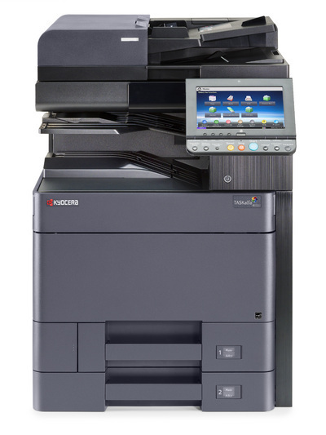

Figure 5 TASK alfa 5053ci multifunctional printer

**ICT Department.**

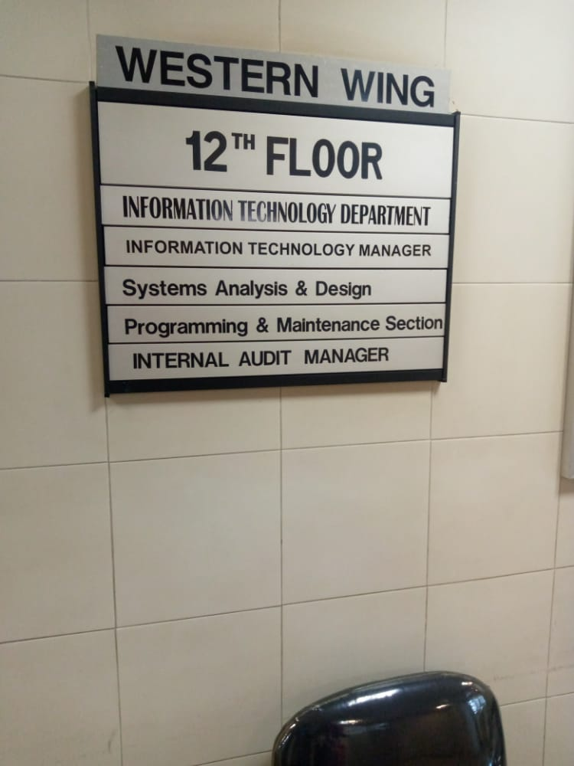

Figure 6 ICT Department.

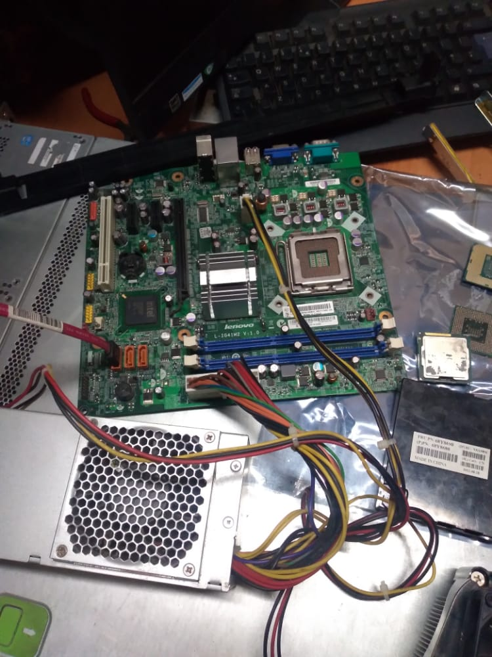

Figure 7 Learning Components of a computer motherboard.

|  |
| --- |
|  |

**Guidelines for students on industrial attachment**

1. To observe all the rules and regulations of the Fund.
2. To carry out the instructions of the supervisor all the time.
3. To work full normal hours, unless instructed otherwise and report to duty on time.
4. Do not absent yourself from work without permission. To ask for permission from the Department/Branch and inform the Training Section.
5. Dress appropriately. Be smart and clean.
6. Supervisor is responsible for the day-to-day work and student must be part of the team.
7. On completion of the industrial attachment, write a report, do a clearance and submit it to HRM.
8. Recommendation letters will be issued on completion of attachment.